# Cloud Application Development

# Data Warehousing with IBM Cloud Db2 Warehouse-Phase 4

To Do:

Building the data warehouse by implementing ETL processes and enabling data exploration. Implement ETL processes to extract, transform, and load data into the data warehouse. Enable data architects to explore and analyze data within Db2 Warehouse using SQL queries and analysis techniques.

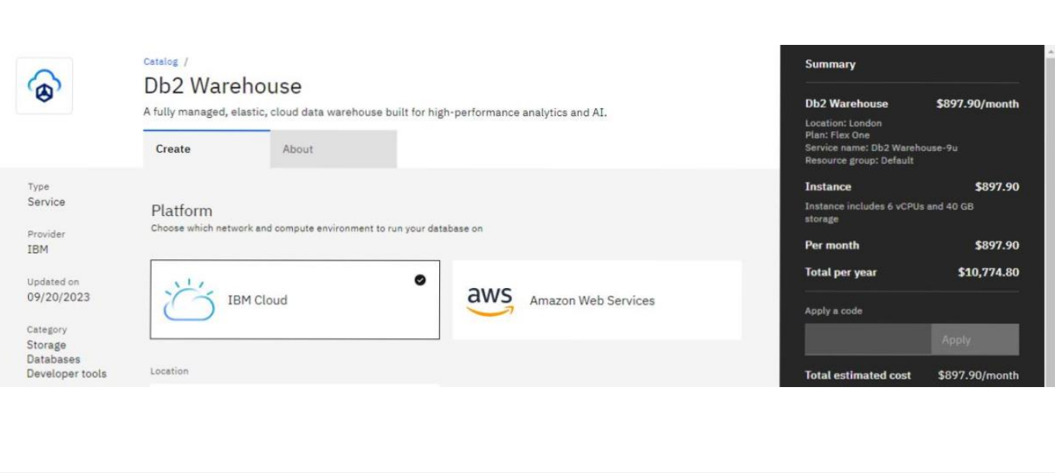

Project Goals :

Building the dataware house

primary goal was to create a data warehouse infrastructure using IBM Db2 Warehouse. Implementing.

Implementing the ETL processs:

We aimed to establish efficient ETL processes to extract, transform, and load data into the data warehouse.

Eg :

Extract data from a source (e.g., CSV file)

INSERT INTO TargetTable (Column1, Column2, Column3)

SELECT SourceColumn1, SourceColumn2, SourceColumn3

FROM SourceCSV;

Enabling Data Exploration:

The project aimed to provide data architects with the tools and capabilities to explore and analyze data within Db2 Warehouse using SQL queries and analysis techniques.

Basic SQL Query:

Retrieve data from a table

SELECT Column1, Column2

FROM WarehouseTable

WHERE Condition = ‘Value’;

Joining Tables:

Join multiple tables for more complex queries

SELECT W.ColumnA, T.ColumnX

FROM WarehouseTable

WINNER JOIN AnotherTable T ON W.ID = T.ID;

Aggregation and Analysis:

Perform aggregate functions for analysis

SELECT Year, SUM(Sales) AS TotalSales

FROM SalesData

GROUP BY Year;

Project Milestones and Achievements :

1. Data Warehouse Implementation :

Successfully deployed IBM Db2 Warehouse, providing a scalable platform for data storage and management.

1. ETL Process Implementation :

Designed and implemented ETL processes that automate data extraction from various sources, perform necessary transformations, and load data into the warehouse.

Achieved data integration across different systems, ensuring a unified and consistent data source.

1. Enabling Data Exploration

Provided data architects with access to Db2 Warehouse, including necessary permissions and credentials.

Facilitated the use of SQL queries and data analysis techniques, empowering data architects to explore the data effectively.

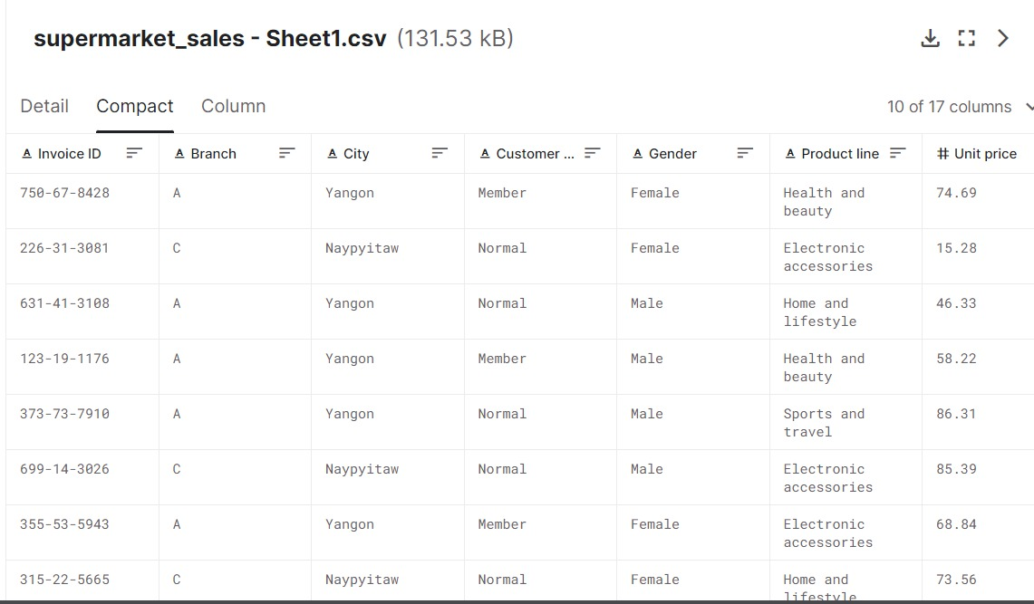

The above spread sheet consist of various data :

Transaction :

This column records the data of each transaction details which can be helpful for tracking and reference.

Product description :

A description of the products or items sold,including their names,brands and relevant details.

Price :

Price column will shows the price of the product where customer was bought.

Product line :

The productline column will shows the sector where the product comes from like health and beauty,Electronics,Lifestyle etc.,

Customer information:

The information column consist of details of the customer like phone no,name,place and gender.

This sheet was the sample spread sheet we used to describe our project.when our final project was done we will use our own spread sheet which was taken form the database.

Conclusion :

This project successfully accomplished the goals of building a data warehouse, implementing ETL processes, and enabling data exploration using IBM Db2 Warehouse. The result is a robust infrastructure that supports data-driven decision-making and analysis.